**Systems Modeling to Measure Performance and Evaluate Management Alternatives to Improve River and Riparian Habitat Quality**

**Authors**

Ayman H. Alafifi and David E. Rosenberg

PhD Candidate Department of Civil and Environmental Engineering and Utah Water

Research Laboratory, Utah State University, Logan, UT, [aafifi@aggiemail.usu.edu](mailto:aafifi@aggiemail.usu.edu)

Associate Professor, Department of Civil and Environmental Engineering and Utah Water

Research Laboratory, Utah State University, Logan, UT, [david.rosenberg@usu.edu](mailto:david.rosenberg@usu.edu)

September 2016

**Systems Modeling to Measure Performance and Evaluate Management Alternatives to Improve River and Riparian Habitat Quality**

**Abstract**

The suitability of watershed habitat to support the livelihood of its biota primarily depends on managing flow. Ecological restoration requires finding opportunities to reallocate available water in a watershed to increase ecological benefits and maintain other beneficial uses. We present the Watershed Area of Suitable Habitat (WASH) systems model that recommends reservoir releases, streamflows, and water allocations throughout a watershed to maximize the ecosystem habitat quality. WASH embeds and aggregates area-weighted metrics for aquatic, floodplain, and wetland habitat components as an ecosystem objective to maximize, while maintaining water deliveries for domestic and agricultural uses, mass balance, and available budget for restoration activities. The metrics add spatial and temporal functionality and area coverage to traditional habitat quality indexes and can accommodate multiple species of concern. We apply the WASH model to the Utah portion of the Bear River watershed which includes 8 demand sites, 5 reservoirs and 37 nodes between the Utah-Idaho state line and the Great Salt Lake. We recommend water allocations to improve current conservation efforts and show tradeoffs between human and ecosystem uses of water. WASH results are displayed on an open-source web mapping application that allows stakeholders to access, visualize, and interact with the model data and results and compare current and model-recommended operations. Results show that the Bear River is largely developed and appropriated for human water uses. However, increasing reservoirs winter and early spring releases and minimizing late spring spill volumes can significantly improve habitat quality without harming agricultural or urban water users. The spatial and temporal reallocation of spring spills to environmental uses creates additional 7 thousand acres of suitable habitat in the watershed for priority species. WASH also quantifies the potential environmental gains from conserving water and thus helps planning for the future of our water resources and ecosystem.

1. **Introduction**

Rivers and their riparian and wetland areas provide numerous services for humans, including domestic and agricultural water supply, recreation and power generation in addition to providing key ecological functions, such as food and habitat, that contribute to sustaining ecosystem health (Delisle and Eliason 1961, Frisell and Ralph 1998). While policy makers acknowledge the need to allocate water to maintain a healthy and functioning riverine ecosystem, human beneficial water uses still receive the highest priority (Jager and Rose 2003, Bunn and Arthington 2002, Magilligan and Nislow 2005, Petts 2009) and are subject to immense pressure from water resources regulations. Failing to allocate water for ecological needs lead to alterations in flow regimes required for species to survive (Poff et al. 1997, Nilsson et al. 2005). For example, water depth influence temperature variation and available dissolved oxygen and thus delimits the physical space available for fish spawning and assemblage (Soar and Thorne 2001). Also, the timing of overbank inundation is crucial for riparian vegetation to successfully reestablish new generations (Meier and Hauer 2010). Regulated rivers provide an opportunity for managers to restore and protect invaluable habitat (Tharme 2003, Jager and Smith 2008) by managing the magnitude, times and durations of reservoir releases and diversions.

Allocating water for ecological habitat, however, is not an easy task. First, managers need to identify priority aquatic, floodplain and wetlands flora and fauna species to conserve or restore. Then, they need to define adequate habitat environment conditions for different life stages of each priority species and mathematically quantify the species ecological response to alterations in habitat attributes such as flow or water depth (Marsh and Cuddy 2010, Kingsford et al. 2010). Next, managers need tools to spatially and temporally map species need of water and make decisions on the volumes and times of diversions, reservoir releases, and impounded wetlands gate operations to meet ecological needs without compromising human water use (Szemis et al. 2012, Paredes-Arquiola et al. 2013, Merritt et al. 2010, Jha et al. 2008). Finding alternatives to achieve the latter management step of this process can be computationally difficult given that flow release decisions have to be temporally and spatially coordinated between different flow controlling infrastructure (and entities) at the watershed.

The competing demand for scarce water quantity pushed forward the development of several methods to quantify environmental instream flow requirements for different species (Stewardson and Webb 2010). Poff et al. (1997) developed the natural flow paradigm to allocate water to mimic important features of natural flow regime such as timing, duration, magnitude and frequency. This method assumes that historical natural flows are both known and adequate for existing ecosystem functions (Baron et al. 2002). Other methods use flow-ecology relationships that are based on the tradeoffs between flow alternation and habitat conditions. The Instream Flow Incremental Methodology (IFIM; Stalnaker 1995), for example, was developed to measure and determine the relationship between stream hydraulics and riverine habitat. The Hydrologic Engineering Center of the US Army Corps of Engineers later developed the Ecosystem Function Model (HEC-EFM; Hickey and Fields 2013) that utilizes habitat quality indexes to produce a single flow value for each ecosystem variable. In addition, the Ecological Limits of Hydrologic Alteration framework (ELOHA; Poff et al. 2010) uses a holistic approach to define environmental flows on the regional level. The common requirements for all these methods is the need to use quantitative and site-specific flow-ecology response models.

Flow-ecology models are constructed using indexes that describe the suitability of a habitat to sustain the survival and productivity of a single or multiple species. The value of these indexes is measured based on a single habitat attribute such as instream water depth, water temperature, etc. (Hemker et al. 2008, Hooper 2010, Pinto et al. 2009). The Habitat Suitability Index (HSI; U.S. Fish and Wildlife Service 1981) is a common example of ecological habitat quality indexes that are used to describe ecological response to alterations of flow. However, HSIs have been criticized in ecological literature because it only reports instantaneous habitat suitability at the times and locations of field measurements (Giller 2005, Woolsey et al. 2007, Palmer et al. 2005). Ecological models that use HSI are likely to provide site-specific, and time-limited results (Merritt et al. 2010, Stewardson and Webb 2010, Stewart-Koster et al. 2013). These model do not report uncertainty in ecological systems (Ascough et al. 2008, Barry and Elith 2006, Mowrer 2000). IFIM, for instance, uses HSI relationships to predict long-term fish population changes with physical habitat alterations (Souchon and Capra 2004). Nonetheless, IFIM results are highly sensitive to the spatial variations of cross sections (Clifford et al. 2008) and are imprecise where vegetation cover and growth alters the flow-stage relationship (Hearne et al. 1994). Nonetheless, habitat suitability indexes continue to be largely used to regulate minimum flows and communicate the success (or failure) of habitat management projects (see, for example, Gibbins and Acornley 2000). Here, we propose that adding spatial and temporal functionalities to habitat quality indexes will significantly improve our ability to allocate water to all users in the watershed. However, this can be rather complicated given the competing demands for water between species, water requirements for different life stages of each species, and temporal and spatial dependency between flow control infrastructure. Embedding habitat quality indexes in a systems model as performance indicators helps recommending better alternatives to allocate resources (i.e. water, budget, etc.) to increase ecological outcomes.

1. **Habitat Quality in Systems Models**

Systems models mathematically quantify interconnections between habitat hydrologic and ecological components and management decisions (Paredes-Arquiola et al. 2013, Munoz-Mas et al. 2012). Managers use systems optimization models to find the best (maximum or minimum) value of one or multiple objectives such as hydropower yield by adjusting the values of several decision variables that they have control over like reservoir releases given system natural, physical and management constraints such as budget (Lethbridge et al. 2010, Orsi et al. 2011, Gómez et al. 2013, Yang 2011, Cioffi and Gallerano 2012). Systems models have been largely used to guide ecological habitat decision making in regulated river systems (Jager and Rose 2003). Most hydrological models define ecological needs as limiting constraints on flow (Jager and Smith 2008, Homa et al. 2005). This is more evident in reservoir management models that maximize energy production potentials while maintaining a static (often regulated) minimum instream flow for fish spices (see, for example, Cioffi and Gallerano 2012, Harman and Stewardson 2005, Ryu et al. 2003, Null et al. 2014). Conversely, fewer models try to maximize ecological functions to improve habitat for priority species (e.g. O’Hanley 2011) or use a multi-objective approach to find the tradeoffs between human and environmental needs (Yang 2011, Kuby et al. 2005, Simonović and Nirupama 2005). Nonetheless, ecological models largely neglect competing ecological objectives between different species at different watershed habitats (i.e. aquatic, floodplains and wetlands) and thus allocate environmental flows for different species individually (e.g. Bash and Ryan 2002, Roni et al. 2002, Wohl et al. 2005, Shiau and Wu 2013). Few studies developed ecological models to address multiple habitat environments. For example, Higgins et al. (2011) developed a nonlinear integer optimization model to mimic natural flow regimes for rivers, floodplains and wetlands habitat to improve ecosystem health. However, achieving such objective is not feasible (Meier 1998) or unrealistic (Jager and Smith 2008) in highly regulated rivers. In addition, many ecological models are designed for specific cases in response to degraded conditions of endangered species and do not consider temporal management dependency between water control infrastructure in the watershed (Mouton et al. 2012, Jackson et al. 2001). These models are typically not applicable to other sites and cannot accommodate other species. Szemis et al. (2012) developed an antcolony optimization model (ACO) to schedule environmental flow reservoir releases in river, floodplain and wetlands habitat and used a penalty function to constraint decision variables. Szemis et al. (2013) later employed a multiobjective approach to their ACO model to find the tradeoffs between maximizing ecological outcomes and minimizing water allocations. Although ACO can solve large complex and nonlinear problems, it is limited to finding near-optimum solutions using the survival of the fittest search mechanism (Blum and Roli 2003). In addition, finding optimal solutions is based on probabilistic search for feasible alternatives (Shiau and Wu 2013). Thus, the sequence of search, conditional dependency between decision variables and the assumptions of the starting search points are all important factors that influence the optimal solution value on every iteration. There is still a need for an optimization model that (i) allocates water to maximize ecological benefits at the watershed (ii) considers multiple aquatic, floodplain and wetlands habitats, (iii) accounts for competing ecological needs of water for multiple species and their different life stage-water needs, (iv) considers temporal and spatial dependency between flow control structures at the watershed, (v) meets human beneficial use of available water and (vi) is generic and adaptable to other sites and species.

This paper presents the Watershed Area of Suitable Habitat (WASH) systems optimization model that maximizes the physically-available and suitable habitat area for priority species. WASH captures environmental flow needs for priority species that use or live in river channels and their floodplain and wetland areas. WASH identifies and recommends management strategies and alternatives to allocate scare natural (e.g. water) and management (e.g. financial) resources to different beneficial users to improve habitat quality.

1. **Watershed Area of Suitable Habitat (WASH)**

WASH maximizes available and ecologically suitable area for species of concern by timely and spatially allocate water to aquatic, floodplain and wetlands habitats subject to natural, physical and management constraints. The model formulation is designed to be generic and transferable to other regulated river systems. WASH accepts the addition (or subtraction) of one or multiple habitat quality attributes and species. The model is designed for decision makers with the ability to prioritize reaches, seasons, environmental users and species.

WASH model formulation adjusts the values of instream flow by controlling reservoir releases and storage volumes in addition to diversion volumes. WASH also controls riparian revegetation cover (Figure 1). These decision variables dictate the values of a group of state variables such as water depth, channel cross sectional area, reservoir surface area, storage and flood recurrence. Decision and state variables are the primary factor that managers have control over to improve habitat quality. For example, increasing reservoir releases in the summer will increase the channel water depth which consequently increases the habitat suitability for fish species. Mathematically, habitat suitability is expressed using suitability indexes and are governed by relationships with habitat conditions such as water depth. These relationships are species-dependent and are based on the tolerance of species to changes in habitat condition. We measure sub-indicators by multiplying each suitability index by an affected area. Finally, sub-indicators are aggregated together using spatial and temporal weights to determine the overall WASH value which represents the entire watershed habitat quality (Figure 1). WASH model works with river systems as a group of nodes and links. Figures 2 is a schematic of an example river network that shows how different model elements are linked together.

In the following model formulation, capitalized terms represent variables while lower case terms indicate parameters, functions, or model inputs. The formulation uses the following indexes to describe and define variables and parameters: j=nodes, k=alias of j, dem= demand sites, v= reservoirs, y = fish species, n= vegetation species, t= timesteps (month), s: index for sub-indicators where s1 =Riverine, s2 =Floodplain, s3 =Impounded Wetlands



**Figure 1.** A flow diagram of the WASH systems model components that shows the decision and state variables, model parameters, suitability indexes, performance indicators, objective function and constraints

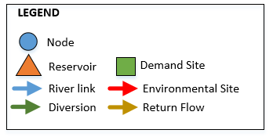

**Figure 2.** A schematic of an example river network of links and nodes and how they are connected. Flow direction follows the arrows on the schematic. Environmental sites are the river segments where habitat for priority species is identified and environmental flows are allocated

***Decision Variables:*** The model has the following decision variables: vegetation cover Cj,k,t,n [Mm2; million square meters], re-vegetated area RVj,k,t,n [Mm2], water depth Dj,k,t [m], flow of water in river link Qj,k,t [Mm3/month], volume of reservoir releases RRv,t [Mm3/t], reservoir storage STORv,t [Mm3], reservoir surface area RAv,t [Mm2]. Other variables include channel surface area Aj,k,t, [Mm2] and channel width WDj,k,t [m].

***Objective Function:*** WASH [Mm2] is composed of the weighted sum of the three indicators (*IND*), riparian [R], floodplain [F] and wetlands [W]. ${wght}_{s,i,t}$ is the spatial and temporal weights for each sub-indicator and can take the value between 0 (not important) to 1 (important).

$Max WASH=\sum_{s,j,k,t}{{wght}_{s,j,k,t}×{IND}_{s,j,k,t}}$-- [1]

***Indicators:*** To calculate the value of each sub-indicator, I first define the relationships between suitability indexes and habitat state variables for each priority species. Whereas multiple species are considered (e.g. two or more fish species), a composite index is calculated by multiplying the values of individual suitability indexes together. The value of each sub-indicator is the multiplication of a suitability index by an affected area. I designed suitability indexes to reflect species response to alterations in flow. These indexes can take a value between 0 and 1 [0: poor to 1: excellent] and are defined based on the Boltzmann Equation for sigmoidal curves:

${SI}_{j,k,t}=c1+ \left[\frac{c2-c1}{1+exp\left(\frac{c3-h_{,k,t}}{c4}\right)}\right], ∀ j,k,t$

Where *SI* is the suitability index value for location (j,k) and time t. *h* is the habitat attribute such as water depth or flow. c1 and c2 are the minimum and maximum SI values. c3 is the EC50 value that represent the habitat attribute value at the middle SI values (i.e. at 0.5), and c4 is the curve slope factor.

1. **Riverine Habitat [${IND}_{riverine}$]:** The presence and abundance of riverine species such as fish is a strong indicator of ecosystem response to flow alterations. Hydraulic variables such as water depth and river connectivity determine fish presence at a site and lead to further exploring suitable other biological factors for relative abundance and community structure (Munoz-Mas et al. 2012, Rayner et al. 2009, Hughes 2007, Growns 2008, Chessman 2006). Riverine habitat suitability sub-indicator R [Mm2] is calculated by multiplying a Riverine Suitability Index (rsi) for each fish species by the channel surface area *A* [Mm2]. rsi [0: poor to 1: excellent] is a function of channel depth *D* [m] and is based on empirical data by Hickman and Raleigh (1982) for fish species water depth requirements at different life stages (Figure 3).

${IND}_{riverine,j,k,t}=\prod_{y}{{rsi}_{j,k,t,y}\left(D_{j,k,t}\right)} ×A_{j,k,t} , ∀ j,k,t$----------------- [2]



**Figure 3.** Aquatic Suitability Index values for water depth for BCT. 3(a) is for adult and juvenile BCT which reaches maximum suitability at 0.75m between Sep. to Mar., and 3(b) is for spawning and fry BCT which reaches maximum suitability at 0.45m between Apr. to Aug.

1. **Floodplain Habitat [${IND}_{floodplains}$]:** Floodplains are the areas adjacent to streams that are inundated regularly. Floodplains are characterized by high water table level that interacts with riparian vegetation roots and keep the soil moist (Meier and Hauer 2010). The lateral connectivity between the river channel and its floodplain area is the primary factor shaping vegetation communities’ composition, abundance and survival (Poff et al. 1997, Merritt et al. 2010, Rivaes et al. 2013, Rood et al. 2005). Successful connectivity means that vegetation recruitment and seed germination coincide with flood events (Meier and Hauer 2010, Merritt et al. 2010, Morrison and Stone 2014, Yarnell et al. 2010) that occurs when the discharge exceeds Bankfull flow. Bankfull is defined at a visible break in slope between the unvegetated bank and adjacent vegetated floodplain surface (Li et al. 2015, Parker et al. 2007). Bankfull discharge is reported to occur, on average, every 1 to 2 years (Leopold et al. 1964, Dunne et al. 1978, Harman and Jennings 1999) and is often associated with the 1.5 year flood recurrence interval (Kilpatrick and Barnes 1964, NOAA 2015, Rosgen 1994). Restoring lateral connectivity for vegetation habitat restoration requires timely managing flow magnitude to exceed bankfull discharge during seed germination season for desired riparian vegetation.

We developed the values of the Floodplain Connectivity Index (FCI) [0 (poor) – 1 (excellent)] as a function of stream flow assuming that a 2-year monthly recurrence flow ${Q2yr}_{j,k,t}$ is sufficient to create a flood event (Figure 4). The value of floodplain connectivity sub-indicator F [Mm2] is calculated by multiplying a suitability index *FCI* by the vegetation cover C [Mm2] for each month *t* and then summing the values for each vegetation species *n* [eq. 3].

${IND}_{floodplains,j,k,t}=\sum_{n}{{FCI}_{j,k,t,n}{(Q2yr}_{j,k,t})×C_{j,k,t,n}}$ $∀ j,k,t$---------------[3]



**Figure 4.** Floodplain Connectivity Index as a function of Flow. Best value achieved at 2-year recurrence flow

1. **Impounded Wetlands [W]:** Maintaining and managing wetlands ecological services requires an understanding of the water requirements that is necessary for the survival of wetland ecosystem (Faulkner et al. 2010, Downard and Endter-Wada 2013). Waterbirds increase their productivity during flood pulses when food items becomes abundant and they tend to migrate at low flows (Rogers and Ralph 2011). Managers can improve wetlands habitat structure and diversity by integrating wetlands water requirements in a systems model and thus controlling volume and timing of available water. Alminagorta et al. (In Review), for example, developed a wetland performance metric and embed it in a system model to measure impounded wetland performance given water availability and other ecological factors. Alminagorta et al. defined Usable Area for Wetlands as performance metric which quantifies the surface area of the wetland whose hydrologic and ecological attributes can support bird species. Usable Area for Wetlands is based on multiplying a composite and weighted suitability index representing species of concern by flooded area of wetland units. The Wetlands Suitability Index (*WSI*) of WASH is based on a similar approach. *WSI* is a composite index that represents the suitability of impounded wetlands to support its species. The value of *WSI* depends primarily on water availability to wetlands (Figure 5). Impounded Wetlands sub-indicator *W* [Mm2] is then calculated by multiplying *WSI* by the impounded wetlands area *aw* [Mm2]. W is used as a performance metric to quantify suitable wetlands area as shown in eq. [4].

${IND}_{wetlands,j,k,t}={WSI}_{j,k,t}\left(Q_{j,k,t}\right) ×{aw}_{j,k,t} , ∀ j,k, t$---------------------- [4]

**Figure 5.** An example ofWetlands Suitability Index as a function of monthly flow in the month of February

***System Constraints:*** Managers are bounded by a set of physical, infrastructure, and management constraints. These constraints include:

* 1. A mass balance requires that reservoir storage at the beginning of time step t+1 must equal storage [Mm3/month] at the beginning of time step t plus the net surface and ground inflows [Mm3/month] minus the reservoir releases [Mm3/month] and evaporation losses [Mm3/month]. : is the reservoir area [Mm2] as a function of reservoir storage [Mm3] and : is the net losses on the links as a fraction

----- [5]

* 1. Mass balance at each node j. k is an alias of j for network analysis

${reachGain}_{j,t}+ \sum_{k}{Q_{k,j,t}\left(1-{lss}_{k,j,t}\right)- \sum_{k}{A_{k,j,t}×{linkEvap}_{k,j,t} ≥ }}\sum_{k}{\left[Q_{j,k,t}\right] ∀j,t}$----[6]

Where *reachGain* describes the flows received by node j from external sources that are not modeled in the network such as head flow, tributaries, etc. *linkEvap* describes the evaporative losses on links [m]

* 1. Mass balance at demand sites:

$\sum_{k}{Q_{k,dem,t}\left(1-{lss}_{k,dem,t}\right)- \sum_{k}{Q_{k,dem,t}} ×{Cons}_{dem,t}≥} \sum_{k}{Q_{dem,k,t}} ∀dem,t$----- [7]

Where ${Cons}_{k,dem,t}$ is the consumptive use fraction expresses as a percentage of inflow received at demand site *dem*

* 1. Channel Topography:
  2. Stage-flow relationships: $D_{j,k,t}={sf}_{j,k}{\left(Q_{j,k,t}\right)}^{}$ $∀ j,k,t$----- [8]
  3. Width-flow relationships: ${WD}_{j,k,t}={wf}_{j,k}{\left(Q_{j,k,t}\right)}^{}$ $∀ j,k,t$----- [9]
  4. Channel surface area: $A_{j,k,t}= {WD}_{j,k}×{lng}_{j,k } ∀ j,k,t$---- [10]

$A_{j,k,t}$: Channel surface area [Mm2], = Length of river segment [m], ${WD}_{j,k,t}:channel width$ [m]. $sf$ and $wf$ are parameters to define stage- and width-flow relationships

* 1. Vegetation mass balance: where vegetation cover [Mm2] at any time *t* is a function of the cover at time *t-1* plus the re-vegetated area [Mm2] for every *n* species

---- [11]

* 1. Reservoir storage ${STOR}_{t}$ cannot go below inactive storage *minstor*v and cannot exceed storage capacity maxstor*v,t* at any time: ${minstor}_{v}≤ {STOR}_{v,t} ≤{maxstor}_{v}$ $∀v,t$---- [12]
  2. Diversions to demand sites Qj,dem,t should meet demand requirements dReqd,t, but cannot exceed diversion capacity dcap: --- [13]

----- [14]

* 1. River flows must meet existing minimum instream flow requirements (instreaReqj,k,t [ha-m/month]): $Q_{j,k,t}≥{{instreamReq}_{j,k,t}}^{}$ $∀j,k,t$----- [15]
  2. Limited financial budget *b* ($) over the planning horizon to implement the management objectives of managing vegetation cover *C* [Mm2]. *cstn* is the unit cost [$/m2] of implementing management objectives that are associated with the revegetating species n in the floodplain sub-indicators *F*. $\sum_{j}{\sum_{k}{\sum_{n}{\sum_{t}{{cst}_{n}}×{RV}_{j,k,t,n } ≤b }}}$------[16]

The nonlinear systems model maximizes the value of the objective function described in eq. [1] WASH performance subject to the constraints in eqs. [5] through [16]. The model formulation is adaptable to other regulated river systems by using different ecological response curves to represent other priority species. The model also encourages stakeholder participation by defining weights that put more emphasis on priority species, sites, and seasons. Section 4 shows the application of this systems model to the Bear River, Utah and the recommendations to improve habitat quality.

1. **Model Application to the Lower Bear River**

I apply the generic model described in section 3 to Utah’s portion of the Bear River (BR) as a case study where ongoing conservation and restoration efforts are underway to allocate water and management resources to preserve and improve ecological habitat. The river (Figure 6) is selected because it is highly disturbed by regulated flow, diversions, and agricultural and grazing activities that threaten the habitat of some nationally-listed endangered species (Bear River Commission 2012). We established a total of three monitoring sites two along the river main stem between Idaho-Utah state line and Cutler reservoir with the first at the Bear River Bottoms near Morton and the second is just below the confluence of the Bear and the Cub Rivers, a major tributary, and a site on the Cub River (Figure 6). We collected flow, water pressure, temperature, channel cross section, floodplain typology, and riparian vegetation identification, cover and distance from the channel through canoeing a 68 km river stretch and visiting the three monitoring sites seven times between August 2012 and August 2015. We use that data to establish stage-flow and width-flow relationships, flow hydrographs, delineate floodplains, measure riparian vegetation cover, and assess changes in channel cross section. Processed hydrologic and ecologic data is available at the Bear River Fellows website: <http://bearriverfellows.usu.edu>. In addition, we supplemented the model with headwater and demand data from the Bear River GenRes model (Adams et al. 1992) that is used by the Utah Division of Water Resources to manage and plan development at the Bear River. We ground truth floodplain areas and measured vegetation cover outside our monitoring sites from the USA NAIP Imagery (USDA 2014). We obtained existing flows from the National Hydrography Dataset (USGS 2012) and its attribute extensions (NHDPlus V2), the USGS gage stations 10092700, 10126000, 10020100, 10020300, 10093000, 10105900, and 10113500 in addition to the USU Little Bear River WATERS Test Bed monitoring sites. We selected 2003 as a representative year that is not too wet or dry and run the model on a 1-year basis to recommend monthly operations of water control infrastructure to allocate water for ecological purposes.

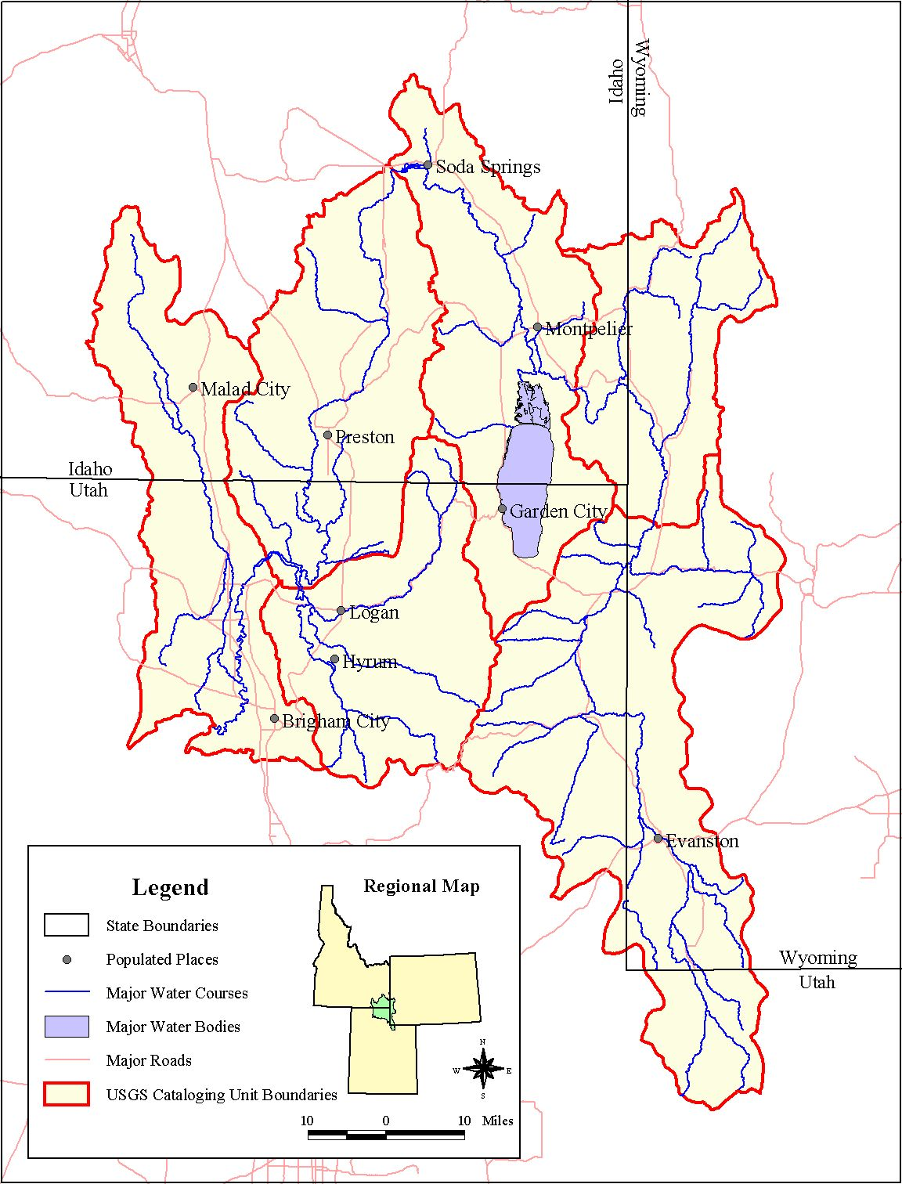

WY

ID

UT

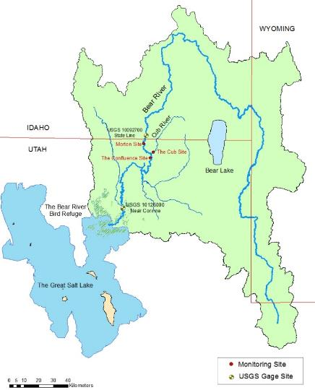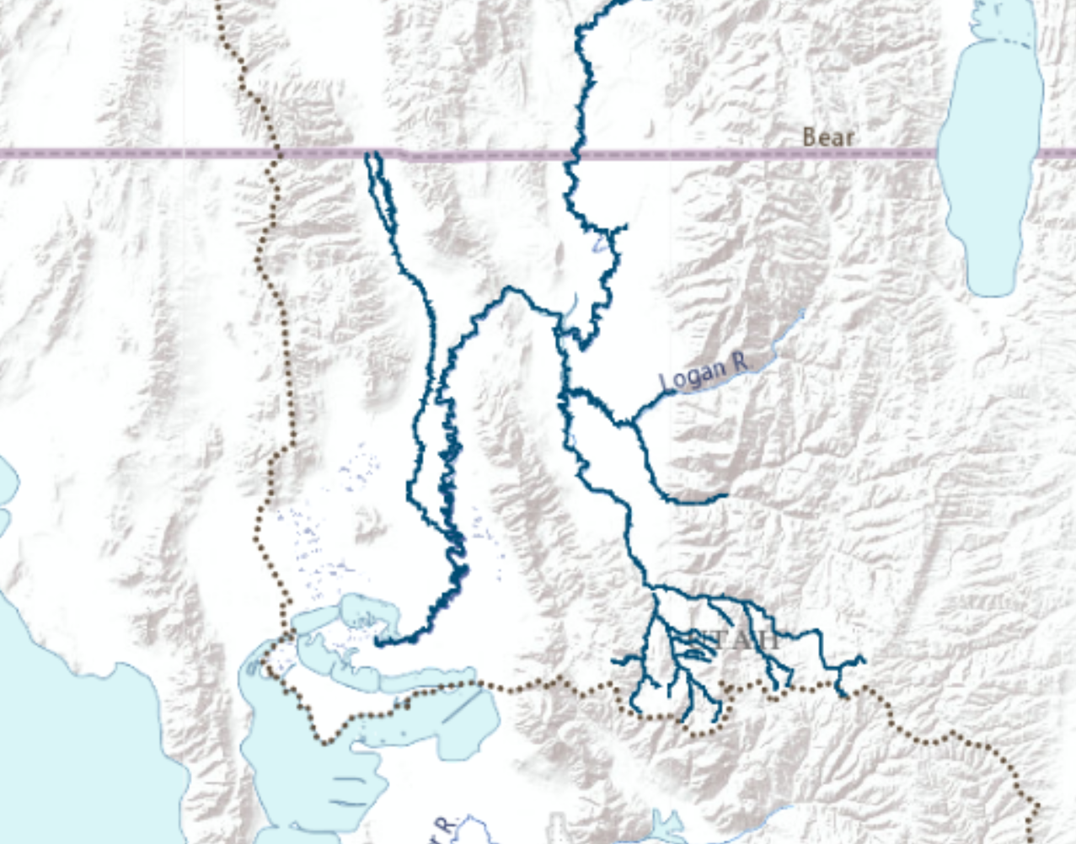

Established hydro-ecologic sites

Existing hydrologic sites

Bear River

Malad River

Cub River

Blacksmith Fork River

East Fork – Little Bear River

South Fork – Little Bear River

The Great Salt Lake

The Migratory Bird Refuge



WY

ID

UT

**Figure 6.** The Utah portion of the Bear River Watershed. Green solid circles show established sites where we collect hydrologlic and ecological data and striped brown circles show sites where hydrologic data is available from other sources

**Selection of priority species**

The presence and abundance of ecological habitat species is a strong indicator of ecosystem response to alterations in flow regime. The application of WASH to the Bear River supports existing conservation and restoration efforts by the Nature Conservancy, Trout Unlimited and local and federal agencies under the Bear River Conservation Action Plan (CAP). We identified priority fish, riparian vegetation and wetlands bird species and their corresponding water needs with the project stakeholders from the CAP team. We use these species as indicator species in the WASH model where we allocate water to maximize their habitat suitability.

* + 1. **Aquatic Habitat:** we selected Bonneville cutthroat trout (BCT; *Onchorynchus clarki utah*) as one of Utah’s native and threatened species (USFWS 2015). BCT is sensitive to changes in water depth, velocity and temperature. Here, we use water depth as the primary abiotic factor in defining habitat suitability. We use water depth here because it is easier to control and measure. Water temperature, on the other hand, is dictated by atmospheric variation and elevation which we do not account for in WASH. We do, however, consider the times of year for BCT different life stages based on the known water temperature at the watershed. River velocity is important to provide slow zones for spawning and poor swimmer fry BCT. Restoration practitioners create these zones by constructing and sequencing artificial pools and riffles (Howe 1997). Using water depth as a proxy for habitat suitability is based on the assumption that when the water depth is low, the flow on the river is typically slower and the water temperature is higher because more surface water is exposed to sun radiation. However, we understand that this simplification is not necessarily accurate in all cases so we refrain from establishing depth-velocity or depth-temperature relationships.

Hickman and Raleigh (1982) established HSI curves for suitable water depth for BCT and determine that BCT needs at least 45 cm of water depth to survive. Braithwaite (2011) carried out an empirical study in the Strawberry River, UT and reported that adult and juvenile trout need about 75cm of water depth. Accordingly, we use 45 cm as the desired water depth for spawning and fry BCT which exist between April – August in the Bear River watershed and 75 cm for juvenile and adult trout between September and March. Based on the flow rating curves of the Bear River and some of its tributaries, these water depths correspond to the instream flows in Table 1.

Table 1: Suitable water depth for BCT at different life stages and the corresponding flows

|  |  |  |  |  |  |  |
| --- | --- | --- | --- | --- | --- | --- |
| **Life Stage** | **Adults/ Juveniles** | | | **Spawn/Fry** | | |
| **Site** | **Depth (m)** | **Depth (ft)** | **Flow (cfs)** | **Depth (m)** | **Depth (ft)** | **Flow (cfs)** |
| Bear River at Morton | 0.75 | 2.46 | 51.92 | 0.45 | 1.5 | 51.9 |
| Bear-Cub Confluence | 44.51 | 44.5 |
| Cub River | 57.30 | 56.5 |
| Bear at Stateline | 37.14 | 37.1 |
| Blacksmith Fork | 16.60 | 16.5 |
| Little Bear at Paradise | 23.14 | 22.9 |
| Little Bear at Mendon | 8.12 | 8.0 |

* + 1. **Floodplain habitat**: we selected cottonwood trees *Populus,* as an indicator native vegetation because it predominates the immediate floodplains in the Lower Bear. Cottonwoods release seeds just after peak flows in snowmelt-driven rivers (Mahoney and Rood 1998, Bhattacharjee et al. 2006). Thus, lateral connectivity is mostly needed between April to June for successful seed dispersion and then through August for continued soil moisture which is crucial for establishment in the first few weeks (Meier and Hauer 2010). Cottonwood trees grow adjacent to the river channel which means that most flow magnitudes over the bankfull flow (1.5year flood recurrence value) will inundate these trees and achieve successful lateral connectivity.
    2. **Wetlands habitat:** The Bear River feeds the 300 km2 Bear River Migratory Refuge. We selected three indicator bird species because they have different shallow, medium and deep water depth needs at different times of the year, thus, covering a large spectrum of the Migratory Birds Refuge water bird needs. These are 1. Black necked stilt (*Himantopus mexicanus*), 2. American avocet (*Recurvirostra americana*), and 3. Tundra swan (*Cygnus columbianus*). Therefore, the suitability index for wetlands habitat is a composite index that takes into consideration the competing needs of different bird species to water throughout the year.

**Model Implementation**

We segmented the Bear River and its main tributaries into a network of 37 nodes and 43 links which includes 5 reservoirs, 8 municipal and agricultural demand sites, and 19 environmental sites where ecological species of concern live (appendix I). We implemented the model on a monthly time basis for the year 2003 as a representative year for the base case and then ran additional years for scenario analysis. We ran the model with equal singular weights in order to allocate water without favoring a location, month or species. We coded and implemented WASH model formulation [equations 1 – 16] using the General Algebraic Modeling System software (GAMS; Hozlar 1990) and solved it using the non-linear Branch-And-Reduce Optimization Navigator (BARON) global solver (Sahinidis 1996). The model has approximately 3,800 variables and 4,000 constraints. We used Excel and R to post-process the model results. All model input data, code and post-processing files are available on this GitHub repository: <https://github.com/ayman510/WASH>

**Model Visualization**

The model is designed as a tool for managers to understand the implications of their decisions on habitat quality. WASH results are displayed on an open-source web mapping application that allows stakeholders to access, visualize, and interact with the model data and results. The web app displays the model recommended flows and reservoir releases and storage volumes and compares them current operations. The app also displays the temporal variations of aquatic, floodplain and wetlands habitats using a time slider. Model data and results are accessible through the web app which also allows users to input their own map and data layers to customize the tool. The web app is available at: <http://goo.gl/YcjBuZ>

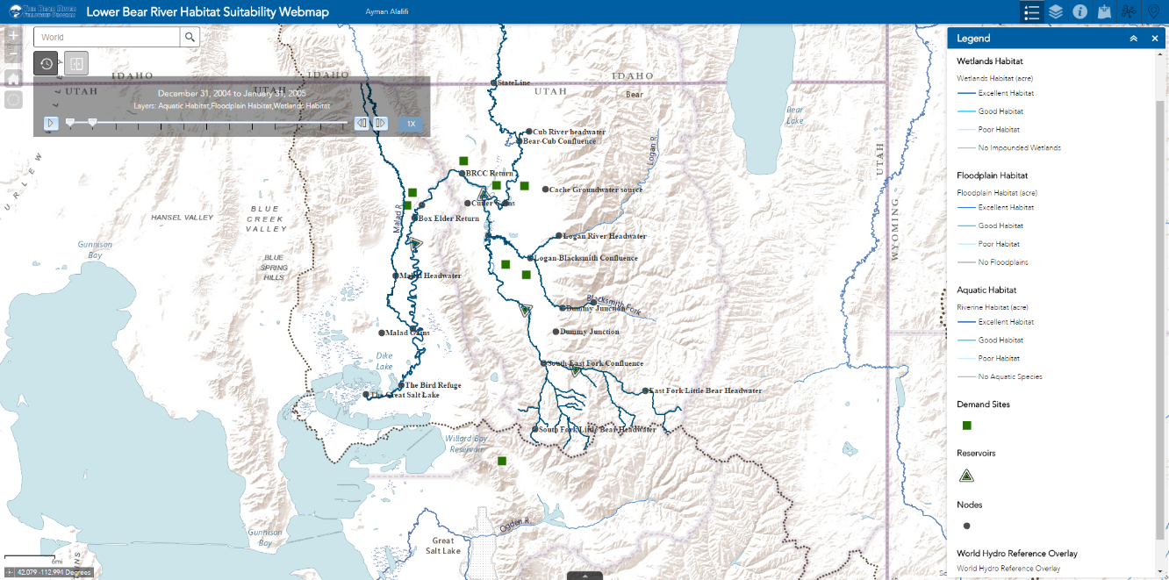**5. Results**

**Figure 7.** Web mapping app that shows the results of applying WASH on the Bear River Watershed. The app is available at: <http://goo.gl/YcjBuZ>

Implementing WASH optimization model for the Bear River network (appendix I) provides insights to the opportunities to improve habitat conditions for priority species. The model outputs comprise time series of recommended monthly reservoir releases, storage and diversion volumes to provide better habitat conditions at the watershed. Accordingly, the outputs show the recommended flows at every river link in the network and the corresponding habitat suitability conditions for aquatic, floodplain and wetlands species. Model outputs also show the corresponding channel depth and width in addition to recommended revegetation area. We ran multiple scenarios to compare the model recommendations for the base case against existing flow control operations, additional species, and different hydrologic conditions. The results are displayed in US Customary Units to better communicate with stakeholders.

Running the model for the base case scenario (for the year 2003) shows that the WASH performance indicator value is nearly 249.7 thousand acres of suitable habitat area for the priority species defined in the river, floodplains and wetlands. This habitat area is achieved by managing the flow control infrastructure in the watershed to allocate water for environmental users. We compare recommended operations to existing ones to show the opportunities to improve management decisions. For instance, WASH recommends increasing reservoir winter and early spring releases at Hyrum Reservoir and minimizing late spring spill volumes in May (Figure 8). The recommended operation of Hyrum serves both human uses during summer months and provides water for environmental users throughout the year. Similarly, we recommend managing spring spills from Porcupine Reservoir in order to provide more water for environmental users (Figure 9).

Figure 8: Hyrum Reservoir Operations

Figure 9: Instream Flow Below Porcupine Reservoir

The value of WASH performance indicator varies between different river segments in the network depending on available water and available habitat area which is constrained by channel geometry, river length, floodplain topology and diked wetlands area. Figure 10 shows an example of a river reach and the measured aquatic and floodplain suitable habitat areas (in acres). It is noted that the suitable floodplain area occurs between April – August which is the required time framed for cottonwoods to have lateral connectivity with the river channel.

Figure 10: Suitable aquatic and floodplain habitat area at a river segment

The model shows the advantage of adding more flow to the network. Table (2) shows the shadow values (Lagrange multipliers) associated with the water mass balance constraint (Equation 6) at the nodes with headwater flow. The shadow values associated with flow show how much more increase in WASH performance indicator (in Mm2) is attained by one additional unit of flow (in Mm3/month). Table 2 shows that the Little Bear River has the most potentials to increase the habitat performance, particularly between August – December.

**Table 2.** Shadow values of additional water increase in the network

|  |  |  |  |  |  |  |  |  |  |  |  |
| --- | --- | --- | --- | --- | --- | --- | --- | --- | --- | --- | --- |
| **Shadow Values/ Month** | **Jan** | **Feb** | **Mar** | **Apr** | **Jun** | **Jul** | **Aug** | **Sep** | **Oct** | **Nov** | **Dec** |
| Bear River (Mm2/Mm3 - month) | 0.12 | 0.03 | 0.03 | 0.03 | 0.03 | 0.03 | 0.42 | 0.04 | 0.06 | 0.04 | 0.06 |
| Cub River (Mm2/Mm3 - month) | 0.12 | 0.03 | 0.03 | 0.03 | 0.03 | 0.03 | 0.42 | 0.03 | 0.06 | 0.04 | 0.06 |
| Blacksmith Fork River (Mm2/Mm3 - month) | 0.12 | 0.04 | 0.03 | 0.03 | 0.03 | 0.03 | 0.42 | 0.03 | 0.07 | 0.07 | 0.07 |
| Little Bear River at East Fork (Mm2/Mm3 - month) | 0.13 | 0.13 | 0.04 | 0.04 | 0.04 | 0.07 | 0.43 | 0.67 | 0.22 | 0.21 | 0.21 |
| Malad River (Mm2/Mm3 - month) | 0.10 | 0.01 | 0.01 | 0.01 | 0.01 | 0.01 | 0.01 | 0.01 | 0.04 | 0.02 | 0.04 |

**Scenario Analysis**

To quantify the added benefits of allocating more water to environmental users, we ran the model in simulation conditions by fixing measured flows on reaches and river segments throughout the watershed and found that nearly 242.4 thousand acres are available and suitable for aquatic, floodplain and wetlands habitat in the watershed (blue diamond, Figure 11). If WASH water allocation recommendations are applied, there is a potential to increase the suitable habitat area to nearly 249.7 thousand acres without harming existing human users (green dot, Figure 11). The suitable area can be further increased if the human water demand is reduced. For instance, if 20% demand reduction is achieved, more water will be available to allocate for the environment and the habitat suitable can potentially increase to 250.2 thousand acres. The environmental gains here are mainly controlled by the volume of water available for reallocation. We ran the model for 2006 as an example of a wet year and 2005 as a dry year and the suitable habitat area increased to 253.3 thousand acres in 2006 (orange triangle) and decreased to 246.6 thousand acres in 2005 (red circle). Figure 13 also shows that the model runs infeasible in the base case scenario (2003) if the human demand exceeds 10% of existing demand volume. This shows that the surface water in the watershed are heavily managed for human consumption.

Figure 11: Tradeoff Analysis between WASH suitable area and annual demand delivery targets

Total Demand

We also examined the model response to additional species. In the base case, we had Bonneville cutthroat trout (BCT) as the single priority fish species in the entire watershed. We received a feedback from the project stakeholders that BCT is not abundant downstream of Cutler Reservoir and bluehead sucker *(Catostomus discobolus)* is the favorable species in that part of the river. We designed the suitability curves for bluehead sucker based on the empirical study of (Anderson and Stewart 2003) where they recommend 0.3m for fry suckers and 0.8m for juveniles and adults (Figure 12). We ran the model with the new spatial distribution of the two fish species and found that WASH performance indicator value is 249.2 thousand acres, an increase of 125 acres from the base case. Since Bluehead sucker requires less water for spawning and fry, WASH was able to assign environmental flows to meet these requirements. However, the increase in suitable area could mean that less water is available to support future development for human use.



Figure 12: Aquatic Habitat Suitability for Bluehead Sucker

**6. Discussion**

The development of WASH followed a participatory approach where stakeholders from the Beat River CAP Implementation team contributed to (i) identifying priority species and locations in the watershed with ecological importance, (ii) provide feedback on suitability indexes used to define ecological response of species to alterations in flow, and (iii) validate model recommendations to adjust flow control operations to improve habitat quality.

The underlying assumption of WASH is that providing adequate and suitable habitat conditions will protect existing selected priority species or encourage their reestablishment. The focus on the physical abiotic habitat environment rather than biotic factors was due to the fact that abiotic attributes are more predictable, measurable and controllable (Soar and Thorne 2001). Accordingly, WASH assumes that hydraulic properties of flow and channel geometry are the primary factors in defining ecosystem health. Other water quality parameters such as temperature and dissolved oxygen, sediment transport dynamics, biotic interactions between species were not considered in the model. This assumption is based on Bunn and Arthington (2002) guiding principles for environmental flows and aquatic habitat which states that flow regimes shape physical habitat health and, in turn, are the major determinant of biotic composition. In addition, flow constitutes longitudinal connectivity (along the river) and lateral connectivity (with the floodplains) which protects the viability of populations. However, WASH formulation can adapt additional suitability indexes if the relationships between flow characteristics and water quality parameters are established.

WASH model formulation uses suitability curves to define ecological response of different species to alterations in flow regimes. We recognize though that habitat suitability indexes (HSIs) are generic and need to be verified with experimental data (Merritt et al. 2010). A before-after monitoring approach is recommended to gauge prescribed instream flows and the response of target species. In our case study, we defined and validated the suitability curves with our stakeholders in order to account for climate, elevation and management aspects. For example, we adjusted the suitability curves for BCT based on an empirical study for a nearby river. We also defined BCT life stages in the mountain areas based on the variations of water temperature throughout the year and designed the suitability curves to reflect that. In addition, we selected the months of the year where cottonwoods germinate seeds in the intermountain region and established the suitability curves to reflect that. Customizing the suitability curves provide useful insights to our stakeholders to implement the model recommendations to benefit the ecosystem.

Implementing WASH recommendations at the Bear River requires that environmental flows to be considered and protected in the water development permitting and planning process. Although Utah’s statute does not allow new appropriations of water for instream flow, the State’s law provides for temporary or permanent transfers of existing rights to environmental users. The mechanisms to acquiring an instream flow right includes donation, lease, or purchase. These transfers are then owned by the Utah Division of Wildlife Resources, the Division of Parks and Recreation or a nonprofit fishing group such as Trout Unlimited and are subject to approval from the State Engineer (Szeptycki et al. 2015). Therefore, we recommend that the additional reservoir releases that WASH recommends to be leased on a short-term basis (less than 5 years) by Trout Unlimited and appropriated for fish usage. This approach reduces administrative burdens and transaction costs, and is more appealing to water right holders because it provides flexibility to changing circumstances and needs.

**7. Conclusion**

This paper introduces the Watershed Area of Suitable Habitat (WASH) performance indicator that we use to measure and quantify suitable habitat area in watersheds. WASH optimization model recommends water allocation to improve river, floodplain and wetlands habitat quality for priority species. WASH solves the complex problem of identifying flow management alternatives to maximize ecological conditions without harming human users. Applying WASH model to the Bear River shows that the river is highly appropriated for human use. However, there are opportunities in the watershed to improve habitat conditions. Comparing model recommended flow operations and existing management show opportunities to increase suitable habitat area by over 7 thousand acres without harming human users. This increase can be achieved by adjusting reservoir storage and release volumes in the watershed to release more water in winter months and reduce spring spills.

Embedding this indicator in a systems model as an objective to maximize helps to recommend management actions to improve habitat quality in the face of scarce water and budget. Performance is defined by three common areas of habitat management within a watershed: aquatic, floodplain and impounded wetland habitats and their associated indicators. These indicators are summed together with weights that vary spatially and temporally and are based on collected data and stakeholder participation. WASH considers multiple aquatic, floodplain and wetlands habitats, accounts for competing ecological needs of water for multiple species and their different life stage-water needs, considers temporal and spatial dependency between flow control structures at the watershed, meets human beneficial use of available water and is generic and adaptable to other sites and species. Applying the model to the Bear River emphasized the importance of managing environmental flows to maintain and improve habitat quality. WASH identified spatial and temporal opportunities to allocate water to species to meet their water requirements through their different life stages. The model results are displayed on an interactive web mapping application to provide managers and practitioners with tools to improve and restore ecological habitat.

**Acknolwedgements**

**References**

Delisle, G.E. and Eliason, B.E. (1961) Stream flows required to maintain trout propulations in the Middle Fork Feather River Canyon, p. 19 pp., Californai Department of Fish and Game.

Frisell, C. and Ralph, S. (1998) River Ecology and Management: Lessons from the Pacific Coastal Ecoregion. R.J. Naiman and R.E. Bilby (ed), pp. 599-624, Springer-Verlag, New York.

Jager, H.I. and Rose, K.A. (2003) Designing Optimal Flow Patterns for Fall Chinook Salmon in a Central Valley, California, River. North American Journal of Fisheries Management 23(1), 1-21.

Bunn, S.E. and Arthington, A.H. (2002) Basic Principles and Ecological Consequences of Altered Flow Regimes for Aquatic Biodiversity. Environmental Management 30(4), 492-507.

Magilligan, F.J. and Nislow, K.H. (2005) Changes in hydrologic regime by dams. Geomorphology 71(1), 61-78.

Petts, G.E. (2009) Instream Flow Science For Sustainable River Management1. JAWRA Journal of the American Water Resources Association 45(5), 1071-1086.

Poff, N.L., Allan, J.D., Bain, M.B., Karr, J.R., Prestegaard, K.L., Richter, B.D., Sparks, R.E. and Stromberg, J.C. (1997) The natural flow regime. Bioscience 47(11), 769-784.

Nilsson, C., Reidy, C.A., Dynesius, M. and Revenga, C. (2005) Fragmentation and Flow Regulation of the World's Large River Systems. Science 308(5720), 405-408.

Soar, P.J. and Thorne, C.R. (2001) Channel Restoration Design for Meandering Rivers U.S. Army Corps of Engineers Washington, DC

Meier, C.I. and Hauer, F.R. (2010) Strong effect of coarse surface layer on moisture within gravel bars: Results from an outdoor experiment. Water Resources Research 46.

Tharme, R.E. (2003) A global perspective on environmental flow assessment: emerging trends in the development and application of environmental flow methodologies for rivers. River Research and Applications 19(5-6), 397-441.

Jager, H.I. and Smith, B.T. (2008) Sustainable reservoir operation: can we generate hydropower and preserve ecosystem values? River Research and Applications 24(3), 340-352.

Marsh, N. and Cuddy, S. (2010) Ecosystem Response Modelling in the Murray-Darling Basin. Saintilan, N. and Overton, I. (eds), CSIRO Australia.

Kingsford, R., Brandis, S., Jenkins, K., Nairn, L. and Rayner, T. (2010) Ecosystem Response Modelling in the Murray-Darling Basin. Saintilan, N. and Overton, I. (eds), CSIRO Australia.

Szemis, J.M., Maier, H.R. and Dandy, G.C. (2012) A framework for using ant colony optimization to schedule environmental flow management alternatives for rivers, wetlands, and floodplains. Water Resources Research 48.

Paredes-Arquiola, J., Martinez-Capel, F., Solera, A. and Aguilella, V. (2013) IMPLEMENTING ENVIRONMENTAL FLOWS IN COMPLEX WATER RESOURCES SYSTEMS – CASE STUDY: THE DUERO RIVER BASIN, SPAIN. River Research and Applications 29(4), 451-468.

Merritt, D.M., Scott, M.L., Poff, N.L., Auble, G.T. and Lytle, D.A. (2010) Theory, methods and tools for determining environmental flows for riparian vegetation: riparian vegetation-flow response guilds. Freshwater Biology 55(1), 206-225.

Jha, R., Sharma, K.D. and Singh, V.P. (2008) Critical appraisal of methods for the assessment of environmental flows and their application in two river systems of India. KSCE Journal of Civil Engineering 12(3), 213-219.

Stewardson, M. and Webb, A. (2010) Ecosystem Response Modelling in the Murray-Darling Basin. Saintilan, N. and Overton, I. (eds), CSIRO Australia.

Baron, J.S., Poff, N.L., Angermeier, P.L., Dahm, C.N., Gleick, P.H., Hairston, N.G., Jackson, R.B., Johnston, C.A., Richter, B.D. and Steinman, A.D. (2002) MEETING ECOLOGICAL AND SOCIETAL NEEDS FOR FRESHWATER. Ecological Applications 12(5), 1247-1260.

Stalnaker, C.B., B.L. Lamb, J. Henriksen, K. Bovee, and J. Bartholow (1995) The Instream Flow Incremental Methodology: A Primer for IFIM. . Washington, DC: US Geological Survey Biological Report 29, 45.

Hickey, J. and Fields, W. (2013) HEC-EFM Ecosystem Functions Model, US Army Corps of Engineers - Hydrologic Engineering Center.

Poff, N.L., Richter, B.D., Arthington, A.H., Bunn, S.E., Naiman, R.J., Kendy, E., Acreman, M., Apse, C., Bledsoe, B.P., Freeman, M.C., Henriksen, J., Jacobson, R.B., Kennen, J.G., Merritt, D.M., O'Keeffe, J.H., Olden, J.D., Rogers, K., Tharme, R.E. and Warner, A. (2010) The ecological limits of hydrologic alteration (ELOHA): a new framework for developing regional environmental flow standards. Freshwater Biology 55(1), 147-170.

Hemker, T., Fowler, K.R., Farthing, M.W. and von Stryk, O. (2008) A mixed-integer simulation-based optimization approach with surrogate functions in water resources management. Optimization and Engineering 9(4), 341-360.

Hooper, B. (2010) River basin organization performance indicators: application to the Delaware River basin commission. Water Policy 12(4), 461-478.

Pinto, R., Patricio, J., Baeta, A., Fath, B.D., Neto, J.M. and Marques, J.C. (2009) Review and evaluation of estuarine biotic indices to assess benthic condition. Ecological Indicators 9(1), 1-25.

Giller, P.S. (2005) River restoration: seeking ecological standards. Editor's introduction. Journal of Applied Ecology 42(2), 201-207.

Woolsey, S., Capelli, F., Gonser, T., Hoehn, E., Hostmann, M., Junker, B., Paetzold, A., Roulier, C., Schweizer, S., Tiegs, S.D., Tockner, K., Weber, C. and Peter, A. (2007) A strategy to assess river restoration success. Freshwater Biology 52(4), 752-769.

Palmer, M.A., Bernhardt, E.S., Allan, J.D., Lake, P.S., Alexander, G., Brooks, S., Carr, J., Clayton, S., Dahm, C.N., Shah, J.F., Galat, D.L., Loss, S.G., Goodwin, P., Hart, D.D., Hassett, B., Jenkinson, R., Kondolf, G.M., Lave, R., Meyer, J.L., O'Donnell, T.K., Pagano, L. and Sudduth, E. (2005) Standards for ecologically successful river restoration. Journal of Applied Ecology 42(2), 208-217.

Stewart-Koster, B., Olden, J.D. and Gido, K.B. (2013) Quantifying flow–ecology relationships with functional linear models. Hydrological Sciences Journal 59(3-4), 629-644.

Ascough, J.C., Maier, H.R., Ravalico, J.K. and Strudley, M.W. (2008) Future research challenges for incorporation of uncertainty in environmental and ecological decision-making. Ecological Modelling 219(3-4), 383-399.

Barry, S. and Elith, J. (2006) Error and uncertainty in habitat models. Journal of Applied Ecology 43(3), 413-423.

Mowrer, H.T. (2000) Uncertainty in natural resource decision support systems: sources, interpretation, and importance. Computers and Electronics in Agriculture 27(1–3), 139-154.

Souchon, Y. and Capra, H. (2004) Aquatic habitat modelling: biological validations of IFIM/Phabsim methodology and new perspectives. Hydroécol. Appl. 14, 9-25.

Clifford, N.J., Acreman, M.C. and Booker, D.J. (2008) Hydrological and Hydraulic Aspects of River Restoration Uncertainty for Ecological Purposes. Darby, S. and Sear, D. (eds), John Wiley & Sons, Ltd, England.

Hearne, J., Johnson, I. and Armitage, P. (1994) Determination of Ecologically Acceptable Flows in Rivers with Seasonal-Changes in the Density of Macrophyte. Regulated Rivers-Research & Management 9(3), 177-184.

Gibbins, C.N. and Acornley, R.M. (2000) Salmonid habitat modelling studies and their contribution to the development of an ecologically acceptable release policy for Kielder Reservoir, North-east England. Regulated Rivers: Research & Management 16(3), 203-224.

Munoz-Mas, R., Martinez-Capel, F., Schneider, M. and Mouton, A.M. (2012) Assessment of brown trout habitat suitability in the Jucar River Basin (SPAIN): Comparison of data-driven approaches with fuzzy-logic models and univariate suitability curves. Science of the Total Environment 440, 123-131.

Lethbridge, M.R., Westphal, M.I., Possingham, H.P., Harper, M.L., Souter, N.J. and Anderson, N. (2010) Optimal restoration of altered habitats. Environmental Modelling & Software 25(6), 737-746.

Orsi, F., Church, R.L. and Geneletti, D. (2011) Restoring forest landscapes for biodiversity conservation and rural livelihoods: A spatial optimisation model. Environmental Modelling & Software 26(12), 1622-1638.

Gómez, C.M., Pérez-Blanco, C.D. and Batalla, R.J. (2013) Tradeoffs in river restoration: Flushing flows vs. hydropower generation in the Lower Ebro River, Spain. Journal of Hydrology (0).

Yang, W. (2011) A multi-objective optimization approach to allocate environmental flows to the artificially restored wetlands of China's Yellow River Delta. Ecological Modelling 222(2), 261-267.

Cioffi, F. and Gallerano, F. (2012) Multi-objective analysis of dam release flows in rivers downstream from hydropower reservoirs. Applied Mathematical Modelling 36(7), 2868-2889.

Homa, E., Vogel, R., Smith, M., Apse, C., Huber-Lee, A. and Sieber, J. (2005) Impacts of Global Climate Change, pp. 1-12, American Society of Civil Engineers.

Harman, C. and Stewardson, M. (2005) Optimizing dam release rules to meet environmental flow targets. River Research and Applications 21(2-3), 113-129.

Ryu, J., Palmer, R., Jeong, S. and Lee, J. (2003) World Water & Environmental Resources Congress 2003, pp. 1-10, American Society of Civil Engineers.

Null, S.E., Medellín-Azuara, J., Escriva-Bou, A., Lent, M. and Lund, J.R. (2014) Optimizing the dammed: Water supply losses and fish habitat gains from dam removal in California. Journal of Environmental Management 136(0), 121-131.

O’Hanley, J.R. (2011) Open rivers: Barrier removal planning and the restoration of free-flowing rivers. Journal of Environmental Management 92(12), 3112-3120.

Kuby, M.J., Fagan, W.F., ReVelle, C.S. and Graf, W.L. (2005) A multiobjective optimization model for dam removal: an example trading off salmon passage with hydropower and water storage in the Willamette basin. Advances in Water Resources 28(8), 845-855.

Simonović, S.P. and Nirupama (2005) A spatial multi-objective decision-making under uncertainty for water resources management. Journal of Hydroinformatics 7(2), 117-133.

Bash, J.S. and Ryan, C.M. (2002) Stream restoration and enhancement projects: Is anyone monitoring? Environmental Management 29(6), 877-885.

Roni, P., Beechie, T.J., Bilby, R.E., Leonetti, F.E., Pollock, M.M. and Pess, G.R. (2002) A review of stream restoration techniques and a hierarchical strategy for prioritizing restoration in Pacific northwest watersheds. North American Journal of Fisheries Management 22(1), 1-20.

Wohl, E., Angermeier, P.L., Bledsoe, B., Kondolf, G.M., MacDonnell, L., Merritt, D.M., Palmer, M.A., Poff, N.L. and Tarboton, D. (2005) River restoration. Water Resources Research 41(10).

Shiau, J.T. and Wu, F.C. (2013) Optimizing environmental flows for multiple reaches affected by a multipurpose reservoir system in Taiwan: Restoring natural flow regimes at multiple temporal scales. Water Resources Research 49(1), 565-584.

Higgins, A.J., Bryan, B.A., Overton, I.C., Holland, K., Lester, R.E., King, D., Nolan, M. and Connor, J.D. (2011) Integrated modelling of cost-effective siting and operation of flow-control infrastructure for river ecosystem conservation. Water Resources Research 47(5), W05519.

Meier, C.I. (1998) Engineering Approaches to Ecosystem Restoration, pp. 386-391.

Mouton, A.M., Dillen, A., Van den Neucker, T., Buysse, D., Stevens, M. and Coeck, J. (2012) Impact of sampling efficiency on the performance of data-driven fish habitat models. Ecological Modelling 245(0), 94-102.

Jackson, D.A., Peres-Neto, P.R. and Olden, J.D. (2001) What controls who is where in freshwater fish communities - the roles of biotic, abiotic, and spatial factors. Canadian Journal of Fisheries and Aquatic Sciences 58(1), 157-170.

Szemis, J.M., Dandy, G.C. and Maier, H.R. (2013) A multiobjective ant colony optimization approach for scheduling environmental flow management alternatives with application to the River Murray, Australia. Water Resources Research 49(10), 6393-6411.

Blum, C. and Roli, A. (2003) Metaheuristics in combinatorial optimization: Overview and conceptual comparison. Acm Computing Surveys 35(3), 268-308.

Rayner, T.S., Jenkins, K.M. and Kingsford, R.T. (2009) Small environmental flows, drought and the role of refugia for freshwater fish in the Macquarie Marshes, arid Australia. Ecohydrology 2(4), 440-453.

Hughes, J.M. (2007) Constraints on recovery: using molecular methods to study connectivity of aquatic biota in rivers and streams. Freshwater Biology 52(4), 616-631.

Growns, I. (2008) The influence of changes to river hydrology on freshwater fish in regulated rivers of the Murray–Darling basin. Hydrobiologia 596(1), 203-211.

Chessman, B.C. (2006) Prediction of riverine fish assemblages through the concept of environmental filters. Marine and Freshwater Research 57(6), 601-609.

Hickman, T. and Raleigh, R. (1982) Habitat Suitability Index Models: Cutthroat Trout, Fish and Wildlife Service.

Rivaes, R., Rodríguez-González, P.M., Albuquerque, A., Pinheiro, A.N., Egger, G. and Ferreira, M.T. (2013) Riparian vegetation responses to altered flow regimes driven by climate change in Mediterranean rivers. Ecohydrology 6(3), 413-424.

Rood, S.B., Samuelson, G.M., Braatne, J.H., Gourley, C.R., Hughes, F.M.R. and Mahoney, J.M. (2005) Managing river flows to restore floodplain forests. Frontiers in Ecology and the Environment 3(4), 193-201.

Morrison, R.R. and Stone, M.C. (2014) INVESTIGATING ENVIRONMENTAL FLOWS FOR RIPARIAN VEGETATION RECRUITMENT USING SYSTEM DYNAMICS MODELLING. River Research and Applications, n/a-n/a.

Yarnell, S.M., Viers, J.H. and Mount, J.F. (2010) Ecology and Management of the Spring Snowmelt Recession. Bioscience 60(2), 114-127.

Li, C., Czapiga, M.J., Eke, E.C., Viparelli, E. and Parker, G. (2015) Variable Shields number model for river bankfull geometry: bankfull shear velocity is viscosity-dependent but grain size-independent. Journal of Hydraulic Research 53(1), 36-48.

Parker, G., Wilcock, P.R., Paola, C., Dietrich, W.E. and Pitlick, J. (2007) Physical basis for quasi-universal relations describing bankfull hydraulic geometry of single-thread gravel bed rivers. Journal of Geophysical Research-Earth Surface 112(F4).

Leopold, L.B., Wolman, M.G. and Miller, J.P. (1964) Fluvial processes in geomorphology, p. 522, W.H. Freeman and Co, San Francisco, California.

Dunne, Thomas and Leopold, L.B. (1978) Water in environmental planning, p. 818, W.H. Freeman Co., San Francisco, Calif.

Harman, W.A. and Jennings, G.D. (1999) River course - Application of the Rosgen stream classification system to North Carolina, North Carolina Cooperative extension service, Raleigh, N.C.

Kilpatrick, F.A. and Barnes, H.H. (1964) Channel Geometry of Piedmont Streams as Related to Frequency of Floods. Interior, U.S.D.o.t. (ed), Washington D.C.

NOAA (2015) High Water Level Terminology, Alaska - pacific River Forecast Center.

Rosgen, D.L. (1994) A classification of natural rivers. Catena (ed), pp. 169-199.

Faulkner, S., Barrow, W., Keeland, B., Walls, S. and Telesco, D. (2010) Effects of conservation practices on wetland ecosystem services in the Mississippi Alluvial Valley. Ecological Applications 21(sp1), S31-S48.

Downard, R. and Endter-Wada, J. (2013) Keeping wetlands wet in the western United States: Adaptations to drought in agriculture-dominated human-natural systems. Journal of Environmental Management 131(0), 394-406.

Rogers, K. and Ralph, T.J. (2011) Floodplain Wetland Biota in the Murray-Darling Basin: Water and Habitat Requirements, CSIRO Publishing.

Alminagorta, O., Rosenberg, D.E. and Kettenring, K.M. (In Review) Systems modeling to improve the hydro-ecological performance of diked wetlands. Water Resources Research Journal.

Bear River Commission (2012) Sixteenth Biennial Report 2009 - 2010, BOUNTIFUL, UTAH.

Adams, T.D., Cole, D.B., Miller, C.W. and Stauffer, N.E. (1992) GENRES A Computer Program System for Reservoir Operation with Hydropower. Resources, U.D.o.W. (ed).

USDA (2014) USA NAIP Imagery: NDVI.

USGS (2012) USA NHDPlusV2.

NHDPlus V2 (2016) NHD Plus V2 Attribute Extensions. Systems, H. (ed), Esri.

USFWS (2015) List of Threatened Species, US Fish and Wild Life Service.

Howe, K. (1997) Construction of Artificial Riffles and Pools For Freshwater Habitat Restoration. Restoration and Reclamation Review 2(1), 5.

Braithwaite, N.R. (2011) The Effect of Stream Restoration on Preferred Cutthroat Trout Habitat in the Strawberry River, Utah, Utah State Univeristy, Logan, UT.

Mahoney, J. and Rood, S. (1998) Streamflow requirements for cottonwood seedling recruitment—An integrative model. Wetlands 18(4), 634-645.

Bhattacharjee, J., Taylor, J. and Smith, L. (2006) Controlled flooding and staged drawdown for restoration of native cottonwoods in the Middle Rio Grande Valley, New Mexico, USA. Wetlands 26(3), 691-702.

Hozlar, E. (1990) Gams - General Algebraic Modeling System for Mathematical-Modeling. Ekonomicko-Matematicky Obzor 26(1), 96-99.

Sahinidis, N.V. (1996) BARON: A general purpose global optimization software package. Journal of Global Optimization 8, 201-205.

Anderson, R. and Stewart, G. (2003) Riverine Fish Flow Investigations. F-289-R6, F.A.P. (ed), Colorado Division of Wildlife Fort Collins, Colorado.

Szeptycki, L.F., Forgie, J., Hook, E., Lorick, K. and Womble, P. (2015) Environmental Water Rights Transfers: A Review of State Laws, Water in the West for The National Fish and Wildlife Foundation, Stanford, CA.

**Appendix 1**



|  |  |  |  |  |  |
| --- | --- | --- | --- | --- | --- |
|  | **Flow (Mm3/month)** | | | | |
| **Recurrence Interval (years)** | **2** | **10** | **25** | **50** | **100** |
| **Bear Stateline** | 180 | 304 | 364 | 407 | 448 |
| **Bear Corinne** | 312 | 591 | 756 | 890 | 1,033 |
| **Bear Cutler** | 119 | 200 | 249 | 290 | 334 |
| **Little Paradise** | 36 | 123 | 212 | 310 | 446 |
| **Blacksmith Fork** | 32 | 79 | 108 | 132 | 157 |
| **Malad River** | 119 | 348 | 506 | 642 | 792 |
| **Cub River** | 48 | 57 | 58 | 59 | 59 |

**Appendix**







Other graphs:

* Reservoir Storage-Area curves
* Stage-Flow rating curves (2 sites poster + others)
* Channel Cross Sections